Recipe

App

Bety Merid 000464085

Jean Andrei Amante 000447040

CSTP 2305 - iOS Mobile App Programming

**Motivation**

Our motivation for making this type of app is mostly due to organization and keeping things stored in an easily accessible way. Sometimes it’s hard to figure out what to eat, or how to go about making new things, so having a recipe book that’s always with you is helpful in overcoming that. The recipe app makes use that you not only have a list of ingredients with you, but also written instructions as well as a video to help make sure you’re making things right.

**Features and specifications**

The app features 5 different food categories:

* Breakfast
* Mexican
* Salads
* Meats
* Deserts

Each category has a list of recipes that correspond to it. Once you click on each recipe a recipe card is shown. Each recipe card has:

* List of ingredients

* Instructions on how to prepare the food

* A YouTube video showcasing how to cook it

* A notes section at the bottom

The notes section allows users to keep their thoughts and experiences together in one place so that if they ever try to make the recipe again they might know how to modify it better to their own personal liking.

Here we have the view for adding the notes. We have the button that when clicked, saves the notes for that recipe, and then also at the button there is a function that allows the user to delete any note by clicking the “trash” symbol.

Here we have the code for how each of the recipe cards are formatted. The order of the code is :

* Image
* Name
* Description
* Video
* Notes

**Project Design**

This is the view for the main page that lists the different food categories you can choose from.

We name the 5 categories at the top with their corresponding picture name.

We have the text that’s displayed at the top of the screen and then we also have the random food button that allows the user to click it and get a random food from any category. We use a lazygrid here to display the categories in columns

**Choosing random food**

When you first enter the app you are met with the categories page. On this page you are able to choose which food category you’d like a recipe for. Or if you aren’t sure what type of food you want to eat you can click the “Get Random Food” button. When you click the button it will randomly choose once of the existing recipes and display it on screen

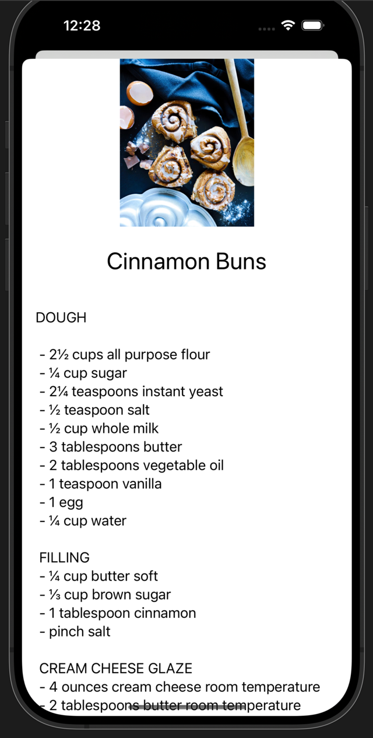

You are able to click the button as many times as you need if you are unhappy with the chosen food

Picking a category**

From here we are given 3 different recipes to choose from, Steak, Chicken Katsu, and Beef Burgers. We’ll be clicking on Beef Burgers

Again from the home screen your able to choose which category you’d like. The 5 categories we have are

* Breakfast
* Mexican
* Salads
* Meats
* Desserts

Lets say for now we click on the Meats category

Also, at the end of the recipe page there is also a YouTube video that you can watch and follow

When we click on it we are shown the recipe page, this will give you the list of ingredients needed for the dish plus instructions on how to make it

**Adding notes**

You can also delete any of the notes by clicking on the red “trash” symbol

After this you are able to see the notes displayed at the very bottom of the recipe card

Lastly, you can also add personalized notes to each recipe card to help you keep track of things. All you would do is click the “Notes” button on the top right corner of the recipe , this prompts the add note form. From here you are able to type in your note, then you click Save